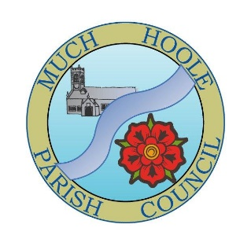 | MUCH HOOLE PARISH COUNCIL  NOTICE OF MEETING
You are hereby summoned to attend the Meeting of Much Hoole Parish Council to be held at 7.30pm on Monday 11th September 2023. The meeting will be held at The Venue (Hoole Village Memorial Hall) on Liverpool Old Road, PR4 4QA.
Tina Hutchinson, Clerk

AGENDA
1. | Apologies for Absence  To receive apologies for absence.
2. | Declaration of Interests and Dispensations  - To receive declarations of interest from Councillors on items on the agenda  - To receive written requests for dispensations for disclosable pecuniary interests (if any)  - To grant any requests for dispensation as appropriate
3. | Minutes of the Previous Meetings  To resolve to approve as a correct record the Minutes of the Council Meeting held on the 12th June 2023
4. | Public Time  To invite and listen to issues raised by members of the public.
5. | Reports from other meetings  The Council will receive reports from meetings where Councillors have attended as representatives.
6. | Off Road Cycle Track  To consider any updates on the Cycle track and resolve any actions required.
7. | Finance  To resolve to authorise payment of the following:  - Pay the Clerk T Hutchinson, in sum of £245.60 (net pay for June)  - Pay HMRC in sum of £61.40 (for T Hutchinson’s June pay)  - Pay JDH Business services in sum of £270.00 (for annual audit)
8. | Planning  N/A none listed under Much Hoole
9. | Village Hall development update  To receive and note a report on the progress of The Venue
10. | Footpaths  To receive an update on footpath issues and proposals re FP11 and FP22 and to review footpath payments.  Discuss signposts that have been damaged and way forward.
11. | Community Garden  Update
12. | Silhouette Poppy Statue  To review quotes for statue
13. | Road Safety Posters  To approve road safety posters quote
14. | Update on progress of Clerk  Audit and budget for Clerk Consultant
15. | Items for next agenda
16. | Date of Next Meeting  The Parish Council to agree the date of the next meeting as 7.30pm Monday 11th September 2023, to be held at ‘The Venue’, Liverpool Road, Much Hoole.

